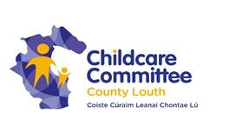

**Childminding Development Grant Available 2018**

**Who is Eligible?**

* Childminders who are providing a childminding service in their own home.
* Thinking of opening a new service in their home.
* No grant available for those who received grant in last 2 years.

**Did you know?**

* Childminders who mind three children or less are not required to notify to TUSLA, but can become voluntary notified to their Local County Childcare Committee.

**Voluntary Notification Benefits:**

* Access to information, support and grant from their Local County Childcare Committee.
* A Tax relief scheme enables childminders to mind up to 3 children and earn up to €15,000 (gross income only) per year tax fee, providing that you inform your local childcare committee of your child-minding service.

**The Childminding Development Grant:**

* Is designed to assist Childminders, already providing a childminding service in their own homes or prospective childminders to enhance the safety/quality in the service through the purchase of small capital items, equipment, toys or minor adaptation costs.
* The maximum grant available to a Childminder who fully meets the criteria of the scheme is €1000.

For further information please contact Louth County Childcare Committee on 0429336364 or email [clerical@louthchildcare.ie](mailto:clerical@louthchildcare.ie)

cid:image001.png@01D0DA65.3EB38990cid:image002.jpg@01D0DA65.3EB38990cid:image003.png@01D15FF8.31C6DF20